archie yarr, AYARR200@caledonian.ac.uk

Wireframes are enclosed

WPD2 Design Doc part 2

All Wireframes

Contents

Wireframes 2

Login Wireframe 2

Register Wireframe 3

Planner Wireframe 4

Add Goal Wireframe 5

Edit Goal Wireframe 6

Remove Goal Wireframe 7

Share Planner Wireframe 8

# Wireframes

## Login Wireframe

## Register Wireframe

## Planner Wireframe

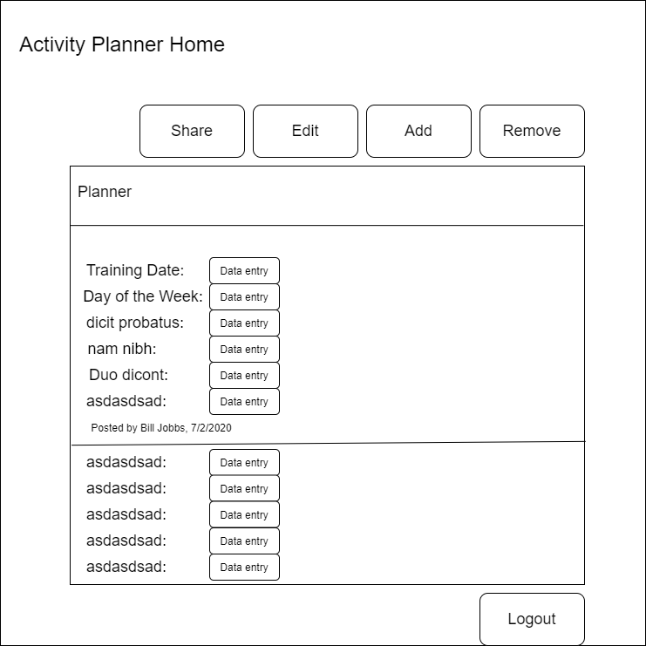

Data entry here is a placeholder for the database data that will be displayed, i.e. “Training Date: 17th March”

## Add Goal Wireframe

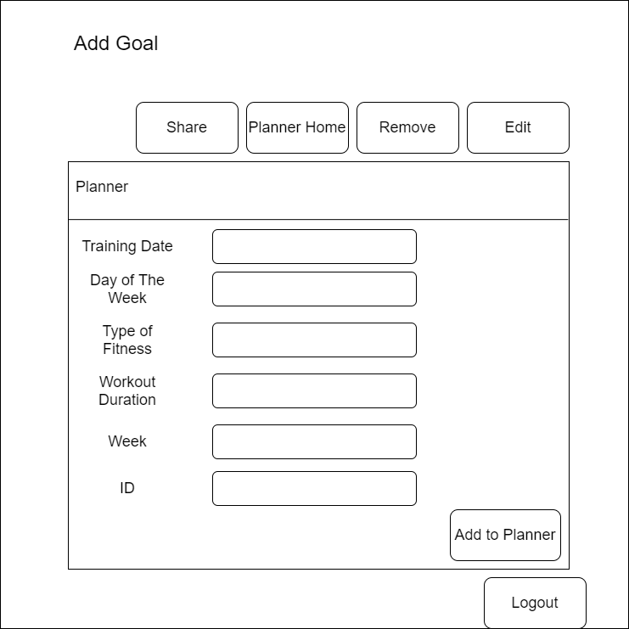

The “Add goal” wireframe shows the data entry boxes that will allow a user to input into the database, changes must be confirmed via the ‘add to planner’ button.

## Edit Goal Wireframe

Similarly to the add wireframe the boxes allow an entry (shown beside each box) to be changed, upon confirmation the change will appear to the user i.e. if March 18th is entered “17th March” will change to “March 18th”

## Remove Goal Wireframe

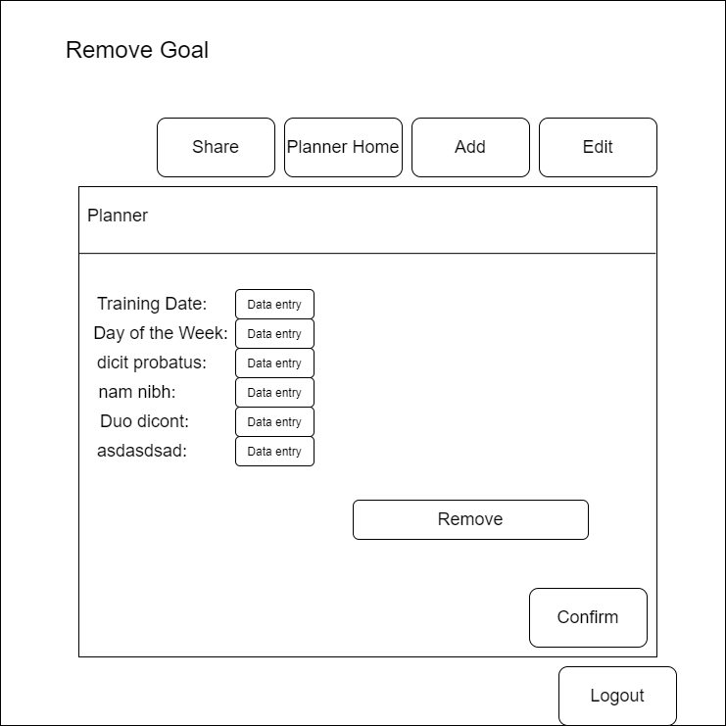

Upon reviewing this wireframe, I am considering changing the rounded remove buttons to a different style as they clash with the unput boxes, although I may make changes to the input boxes instead. I wish to keep the button styling consistent.

## Share Planner Wireframe

